# **CHAPTER 1**

# **INTRODUCTION**

The Smart Irrigation System represents an innovative project set to transform agricultural practices by optimizing water usage and promoting plant health. Through the integration of advanced technology, it ensures precise irrigation, conserving water effectively for sustainable crop cultivation. Our project focuses on smart irrigation, a system designed to efficiently manage water resources while optimizing plant health. By integrating IoT devices like NodeMCU microcontrollers, along with specialized sensors, we're creating a sophisticated solution that's easy to understand and implement.

At the heart of our system lies a soil moisture sensor, which acts as the eyes and ears of the operation, constantly monitoring the moisture levels in the soil. When the soil is adequately hydrated, the system intelligently activates the irrigation pump, ensuring plants receive just the right amount of water they need to thrive. This proactive approach not only conserves water but also prevents waterlogging, which can harm plant roots.

But we're not stopping there. By also incorporating a temperature sensor into our setup, we're adding another layer of intelligence. When temperatures soar beyond a predefined threshold, signaling potential heat stress for plants, our system kicks into action, providing timely irrigation to keep them cool and hydrated. During cooler periods, the system remains idle, conserving water and energy.

Through the seamless integration of IoT technology, our smart irrigation system offers precise control and monitoring, empowering farmers to make data-driven decisions that optimize resource utilization and promote sustainable agriculture. By conserving water while maximizing plant health, we're not just cultivating crops – we're cultivating a greener, more resilient future for farming.

Moreover, the integration of IoT technology enables remote access and control, allowing farmers to adjust irrigation settings or receive alerts on their smartphones, ensuring continuous monitoring and management even when they are away from the field. Furthermore, our smart irrigation solution promotes data-driven decision-making through comprehensive analytics capabilities. By collecting and analyzing data on soil moisture levels, temperature fluctuations, and other environmental parameters over time, farmers gain valuable insights into crop water requirements and growth patterns. This facilitates precision irrigation scheduling, reducing water wastage and optimizing plant uptake of nutrients, ultimately leading to improved crop yields and quality.

Another significant advantage of our smart irrigation system is its potential to integrate with existing farm management software or precision agriculture platforms. By seamlessly exchanging data with these systems, our solution enables holistic farm management, streamlining workflows and enhancing overall operational efficiency. This interoperability also opens up opportunities for future advancements, such as predictive analytics or autonomous irrigation, paving the way for even greater advancements in sustainable agriculture.

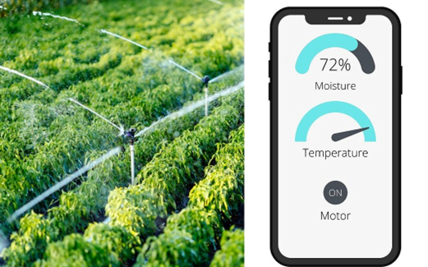

Figure 1.1: Monitoring soil moisture levels and temperature

**1.1: Problem Statement:**

Traditional irrigation methods often rely on fixed schedules or manual monitoring, leading to inefficient water usage and potential risks to plant health. Moreover, variations in environmental factors such as soil moisture levels and temperature can significantly impact irrigation requirements, making it challenging to maintain optimal conditions for plant growth. Inefficient irrigation practices not only waste water but also contribute to increased energy consumption and operational costs for farmers. To address these challenges, there is a need for a smart irrigation system that can adapt to changing environmental conditions and optimize water usage while promoting plant health. Such a system should incorporate sensors to monitor soil moisture levels and temperature in real-time, allowing for precise irrigation scheduling based on actual plant needs.

Additionally, the system should be capable of remote monitoring and control to enable proactive management and timely intervention, even when farmers are not physically present in the field. Therefore, the problem statement for this project is to design and implement a smart irrigation system using NodeMCU microcontrollers, soil moisture sensors, and temperature sensors. The system should automatically activate the irrigation pump when soil moisture levels are low or temperatures exceed a certain threshold, ensuring efficient water usage and preventing plant dehydration. By addressing these challenges, the proposed smart irrigation system aims to promote sustainable agriculture practices while maximizing crop yields and conserving water and energy resources.

**1.2: Problem Scope**:

The scope of smart irrigation management system tailored to optimize water usage and promote plant health. The system's primary function is to gauge soil moisture levels in real-time and activate the irrigation pump when moisture is low, ensuring plants receive adequate hydration while conserving water resources efficiently. Furthermore, the integration of temperature sensors enables temperature-based pump control, preventing plant dehydration during heat stress conditions by activating the pump when temperatures rise above a predefined threshold. Conversely, the system remains inactive during cooler periods to optimize resource utilization and prevent unnecessary watering, thus promoting sustainable agricultural practices. The problem scope also encompasses considerations such as system scalability, adaptability to varying environmental conditions, and compatibility with existing irrigation infrastructure. Additionally, the system should facilitate remote monitoring and control capabilities, allowing farmers to manage irrigation activities from any location and enabling proactive intervention in case of anomalies.

**Traditional Irrigation Challenges:**

Addressing the limitations and inefficiencies of conventional irrigation methods, such as manual monitoring, fixed schedules, and overwatering, which can lead to water wastage, decreased crop yields, and increased operational costs.

**Environmental Variability:**

* Accounting for fluctuations in environmental factors such as soil moisture levels, temperature, humidity, and rainfall patterns, which affect plant water requirements and irrigation scheduling.

**Resource Optimization:**

* Maximizing the efficient use of water, energy, and other resources by implementing precise irrigation scheduling based on real-time data and plant needs.

**Technology Integration:**

* Integrating IoT devices, sensors, and microcontrollers to monitor and control irrigation processes, enabling remote monitoring, data analytics, and automated decision-making.

**Scalability and Adaptability:**

* Designing a flexible and scalable irrigation system that can be customized to different crop types, soil conditions, and geographic locations, ensuring optimal performance across diverse agricultural settings.

**Data Management and Analysis:**

* Developing mechanisms for collecting, processing, and analyzing irrigation data to derive insights, optimize irrigation strategies, and improve overall system performance.

**User Interface and Accessibility:**

* Creating user-friendly interfaces and mobile applications that enable farmers to easily monitor and manage irrigation activities, receive alerts, and make informed decisions.

**Sustainability and Environmental Impact:**

* Promoting sustainable agricultural practices by minimizing water usage, reducing runoff and soil erosion, and mitigating the environmental impact of irrigation operations.

**Regulatory Compliance:**

* Ensuring compliance with local regulations and standards governing water usage, irrigation practices, and environmental conservation.

Overall, the problem scope of smart irrigation encompasses a broad range of technical, environmental, and operational considerations aimed at improving water efficiency, enhancing crop productivity, and promoting sustainable agriculture practices.

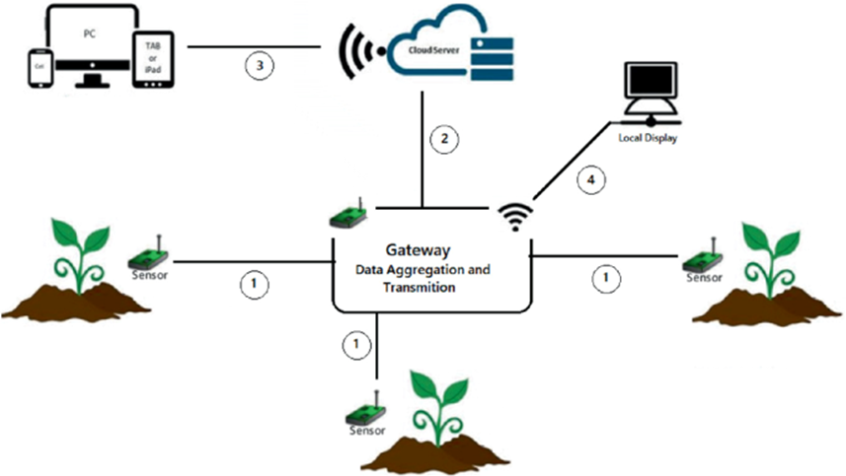

Figure 1.2: Technologies used for monitoring the soil moisture levels and Temperature

**1.3: Advantages of using Smart Irrigation for Agriculture**

The implementation of using Smart Irrigation systems in agriculture leveraging IoT technology are numerous and impactful:

**Water Efficiency:**

* Smart irrigation systems optimize water usage by providing precise irrigation scheduling based on real-time data from soil moisture sensors. This ensures that crops receive the right amount of water they need, reducing water wastage and promoting efficient water usage.

**Improved Crop Health and Yield:**

* By ensuring that plants receive optimal hydration levels and avoiding over or under-watering, smart irrigation systems promote healthier plant growth and increase crop yields. This leads to better quality produce and improved profitability for farmers.

**Resource Optimization:**

* Smart irrigation systems help optimize resource utilization by integrating data from various sensors, such as temperature and humidity, to tailor irrigation schedules based on environmental conditions. This not only conserves water but also minimizes energy consumption and reduces operational costs.

**Remote Monitoring and Control:**

* IoT-enabled smart irrigation systems allow farmers to remotely monitor and control irrigation activities from anywhere using mobile applications or web interfaces. This provides greater flexibility and convenience, enabling farmers to respond promptly to changing conditions and manage irrigation operations efficiently.

**Data-Driven Decision Making:**

* Smart irrigation systems collect and analyze data on soil moisture levels, weather forecasts, and crop water requirements, enabling farmers to make informed decisions about irrigation scheduling and resource allocation. This leads to more precise and effective irrigation management practices, resulting in better crop outcomes.

**Environmental Sustainability:**

* By promoting water conservation and reducing the environmental impact of irrigation practices, smart irrigation systems contribute to environmental sustainability. They help mitigate water scarcity issues, minimize soil erosion and runoff, and preserve natural resources for future generations.

**Scalability and Adaptability:**

* Smart irrigation systems are scalable and adaptable to different crop types, soil conditions, and agricultural settings. They can be customized and expanded as needed to meet the evolving needs of farmers and accommodate changes in environmental conditions.

**Enhanced Automation and Efficiency:**

* By automating irrigation processes and eliminating the need for manual intervention, smart irrigation systems increase operational efficiency and productivity. This frees up valuable time and resources for farmers to focus on other aspects of farm management, ultimately improving overall farm profitability.

In summary, smart irrigation systems leveraging IoT technology offer numerous advantages for agriculture, including water efficiency, improved crop health and yield, resource optimization, remote monitoring and control, data-driven decision-making, environmental sustainability, scalability, adaptability, and enhanced automation and efficiency.

**1.4 Proposed Solution:**

The proposed solution for implementing smart irrigation with NodeMCU involves integrating a soil moisture sensor and a temperature sensor to create an intelligent irrigation system. The soil moisture sensor continuously monitors the moisture levels in the soil, providing real-time feedback to the NodeMCU microcontroller. When the moisture level is high, indicating sufficient hydration for the plants, the NodeMCU activates the relay, turning on the irrigation pump to deliver water to the crops. Conversely, when moisture levels are adequate, the pump remains off, conserving water efficiently. Additionally, by incorporating a temperature sensor, the system can detect temperature fluctuations. If temperatures exceed a predefined threshold, signaling potential heat stress for the plants, the NodeMCU triggers the pump to provide timely irrigation, preventing plant dehydration. During cooler periods, the pump remains inactive to optimize resource utilization. This comprehensive setup ensures precise irrigation management, promoting healthier plant growth while conserving water and energy effectively, ultimately enhancing agricultural sustainability.

**1.5 Aim and Objectives:**

**Aim:**

The aim of implementing smart irrigation with NodeMCU is to revolutionize traditional irrigation practices by leveraging advanced sensor technology and intelligent control mechanisms. By utilizing a soil moisture sensor, the system aims to accurately assess soil moisture levels in real-time, enabling efficient water management. When moisture levels are sufficient, the system activates the irrigation pump to deliver water to the plants, ensuring optimal hydration while conserving water resources during periods of high moisture. Additionally, the integration of a temperature sensor enables the system to respond dynamically to changing environmental conditions. By activating the pump when temperatures exceed a specified threshold, the system prevents plant dehydration and promotes healthier plant growth. Overall, the goal is to achieve precise irrigation control, fostering sustainable agricultural practices while maximizing crop yield and minimizing water and energy consumption.

**Objectives:**

The objectives for implementing smart irrigation with NodeMCU are as follows:

**Efficient Water Management:**

* Utilize the soil moisture sensor to accurately gauge soil moisture levels and activate the irrigation pump only when necessary, ensuring optimal hydration for plants while conserving water resources.

**Temperature-Based Pump Control:**

* Integrate a temperature sensor to monitor environmental conditions and activate the pump when temperatures exceed a predefined threshold, preventing plant dehydration during heat stress conditions and optimizing resource utilization.

**Precise Irrigation Control:**

* Achieve precise control over irrigation activities by implementing intelligent control mechanisms based on real-time data from the soil moisture and temperature sensors, thereby promoting healthier plant growth.

**Sustainability:**

* Promote sustainable agricultural practices by minimizing water and energy consumption through efficient irrigation management, contributing to environmental conservation efforts.

**Enhanced Plant Health:**

* Ensure the well-being of plants by providing timely irrigation based on their moisture and temperature requirements, ultimately enhancing crop health, resilience, and productivity.

**User-Friendly Operation:**

* Design the system to be user-friendly and easily operable, allowing farmers to monitor and control irrigation activities efficiently, thereby facilitating seamless integration into existing agricultural practices.

**CHAPTER 2**

# **Literature Survey**

Smart irrigation systems utilizing IoT technology have emerged as a promising solution to address the challenges of water scarcity and inefficient water usage in agriculture. A key component of these systems is the integration of soil moisture sensors, which enable real-time monitoring of soil moisture levels. Research studies have demonstrated the effectiveness of soil moisture sensors in optimizing irrigation schedules and conserving water resources by ensuring that plants receive the right amount of water they need without overwatering.

Additionally, the incorporation of temperature sensors in smart irrigation systems enables temperature-based control of irrigation pumps. When temperatures exceed a predefined threshold, indicating potential heat stress for plants, the pump is activated to provide timely irrigation and prevent plant dehydration. This proactive approach to irrigation management not only promotes healthier plant growth but also enhances water use efficiency.

Numerous research studies have explored different aspects of smart irrigation using IoT technology, including sensor technology, control mechanisms, optimization strategies, and environmental sustainability. Sensor technology plays a crucial role in smart irrigation systems, providing the necessary data to make informed decisions about irrigation scheduling and resource management. Control mechanisms, such as feedback control loops and predictive algorithms, help regulate irrigation activities based on sensor data and environmental conditions. Optimization strategies, including machine learning algorithms and mathematical modelling, aim to improve the performance and efficiency of smart irrigation systems by minimizing water usage and maximizing crop yields.

Moreover, the environmental benefits of smart irrigation systems have been extensively studied. These systems help conserve water resources, reduce runoff and soil erosion, and minimize the environmental impact of irrigation activities. Economic analyses have also been conducted to evaluate the cost-effectiveness and financial benefits of adopting smart irrigation technologies.

Furthermore, studies have investigated the adoption and adoption barriers of smart irrigation systems, considering factors such as technological readiness, knowledge and awareness, financial incentives, regulatory support, and social acceptance. Understanding these factors is crucial for promoting the uptake of smart irrigation technologies among farmers and stakeholders.

Overall, the literature on smart irrigation using IoT technology highlights its potential to revolutionize agricultural water management practices, promote sustainability, and address challenges related to water scarcity and climate variability. Research highlights the potential cost savings associated with reduced water usage, energy consumption, and labor requirements due to the automation and optimization provided by smart irrigation technologies. Furthermore, studies investigate the scalability of these systems across different agricultural contexts, considering factors such as farm size, crop type, and regional climate variations. Moreover, the integration of smart irrigation with precision agriculture techniques, such as variable rate irrigation and crop-specific watering strategies, is explored to further enhance resource efficiency and crop yields. Additionally, the role of smart irrigation in mitigating water-related challenges such as salinity management, waterlogging, and nutrient leaching is examined. Furthermore, literature reviews emphasize the importance of user acceptance, adoption barriers, and stakeholder engagement in the successful implementation of smart irrigation solutions. By addressing these multifaceted aspects, the literature underscores the transformative potential of smart irrigation in revolutionizing agricultural water management practices and fostering sustainable food production systems in a rapidly changing world.

**CHAPTER 3**

# **Methodology**

The methodology for implementing smart irrigation with NodeMCU involves several key steps to ensure the effective operation of the system. Firstly, the hardware components need to be assembled, including the NodeMCU microcontroller, soil moisture sensor, temperature sensor, relay, and irrigation pump. Once assembled, the NodeMCU is programmed using appropriate software development tools, such as the Adriano IDE, to interface with the sensors and control the relay based on sensor readings.

Next, the soil moisture sensor is calibrated to establish baseline moisture levels for the specific soil type and environmental conditions. This calibration process involves taking measurements at different moisture levels and adjusting sensor settings accordingly to ensure accurate readings. Similarly, the temperature sensor is calibrated to accurately detect temperature variations and trigger the pump when necessary.

Once calibration is complete, the NodeMCU continuously monitors soil moisture levels and temperature readings. When moisture levels are high, indicating sufficient hydration for the plants, the NodeMCU activates the relay, which in turn activates the irrigation pump to deliver water to the plants. Conversely, when moisture levels are adequate and temperatures are within the optimal range, the pump remains off to conserve water and energy.

Additionally, the system includes safeguards to prevent overwatering or under watering. If moisture levels are excessively high or temperatures exceed a predefined threshold, indicating potential risks of waterlogging or heat stress, the NodeMCU disables the pump to avoid detrimental effects on plant health.

Throughout the implementation process, thorough testing and validation are conducted to ensure the accuracy and reliability of the system. This includes testing the response of the sensors to varying soil moisture levels and temperature conditions, as well as assessing the performance of the relay and pump control mechanisms. Any issues or discrepancies identified during testing are addressed through adjustments to the hardware or software components.

Finally, once the system is deemed operational and stable, it can be deployed in agricultural settings for real-world applications. Continuous monitoring and maintenance are essential to ensure the ongoing functionality and effectiveness of the smart irrigation system, allowing for adjustments and optimizations as needed to promote healthier plant growth while conserving water and energy effectively.

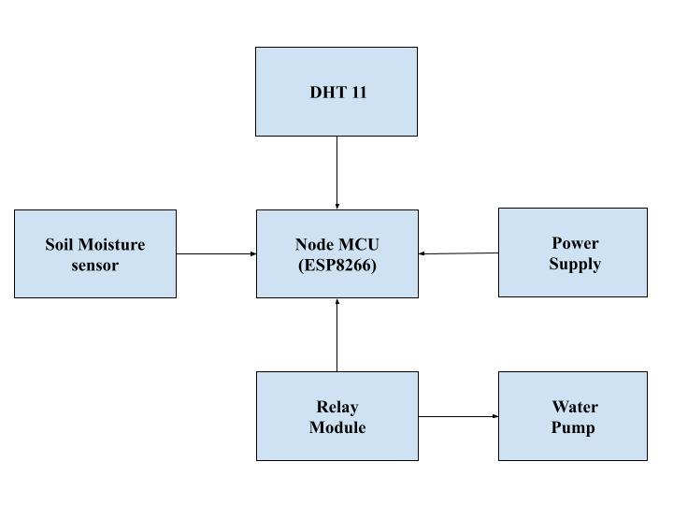Figure 3.1: Block Diagram for Smart Irrigation

**3.1 NodeMCU (ESP8266)**

The NodeMCU ESP8266 is a powerful and versatile platform designed for Internet of Things (IoT) development. The ESP8266 is a cost-effective Wi-Fi microchip known for its capability to enable wireless communication in IoT applications. NodeMCU, on the other hand, is an open-source firmware and development kit that simplifies the process of prototyping and programming the ESP8266. With built-in Wi-Fi connectivity, the NodeMCU ESP8266 allows devices to connect to the internet wirelessly, making it suitable for a wide range of IoT projects. One notable feature is its support for the Lua scripting language, providing a high-level programming environment for developers. Additionally, it is compatible with the Arduino IDE, allowing those familiar with Arduino to use the NodeMCU platform. Equipped with General Purpose Input/output (GPIO) pins, the ESP8266 facilitates interfacing with various electronic components, making it ideal for applications such as home automation and sensor networks. The NodeMCU ESP8266 has garnered significant community support, resulting in an extensive collection of libraries and documentation, making it a popular choice for rapid IoT prototyping and development.

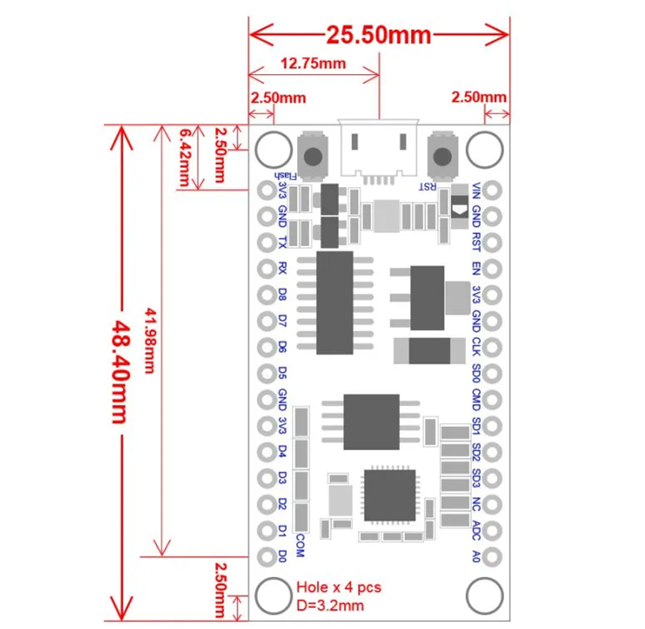

Figure 3.2 NodeMCU 2D View

**NodeMCU Specification:**

The NodeMCU development board is based on the ESP8266 microcontroller, and different versions of NodeMCU boards may have slight variations in specifications. As of my knowledge cutoff in January 2022, here are the general specifications for the NodeMCU ESP8266 development board:

**1. Microcontroller:** ESP8266 Wi-Fi microcontroller with 32-bit architecture.

**2. Processor:** Tensilica L106 32-bit microcontroller.

**3. Clock Frequency:** Typically operates at 80 MHz.

**4. Flash Memory:**

● Built-in Flash memory for program storage.

● Common configurations include 4MB or 16MB of Flash memory.

**5. RAM:** Typically equipped with 80 KB of RAM.

**6. Wireless Connectivity:**

● Integrated Wi-Fi (802.11 b/g/n) for wireless communication.

● Supports Station, SoftAP, and SoftAP + Station modes.

**7. GPIO Pins:** Multiple General Purpose Input/Output (GPIO) pins for interfacing with sensors, actuators, and other electronic components.

**8. Analog Pins:** Analog-to-digital converter (ADC) pins for reading analog sensor values.

**9. USB-to-Serial Converter:** Built-in USB-to-Serial converter for programming and debugging.

**10. Operating Voltage:** Typically operates at 3.3V (Note: It is crucial to connect external components accordingly to avoid damage).

**11. Programming Interface:** Programmable using the Arduino IDE, Lua scripting language, or other compatible frameworks.

**12. Voltage Regulator:** Onboard voltage regulator for stable operation.

**13. Reset Button:** Reset button for restarting the board.

**14. Dimensions:** Standard NodeMCU boards often have dimensions around 49mm x 24mm.

**15. Power Consumption:** Low power consumption, making it suitable for battery-operated applications.

**16. Community Support:** Active community support with extensive documentation and libraries.

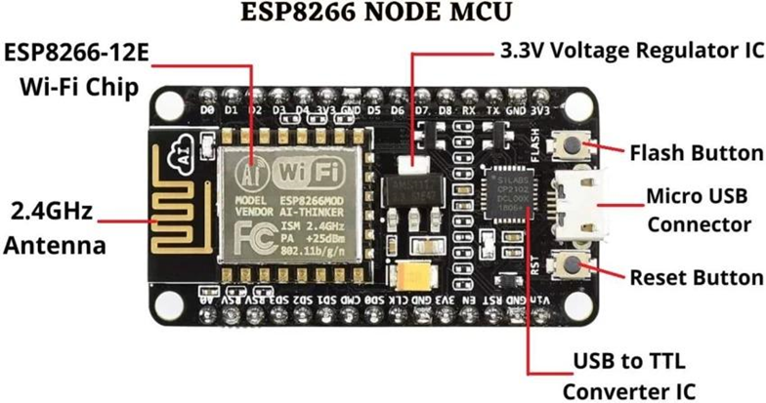

Figure 3.3: NodeMCU Parts

The NodeMCU ESP8266 development board typically has GPIO (General Purpose Input/Output) pins that can be used for various purposes, including interfacing with sensors, actuators, and other electronic components. Below is a common pinout configuration for the NodeMCU development board

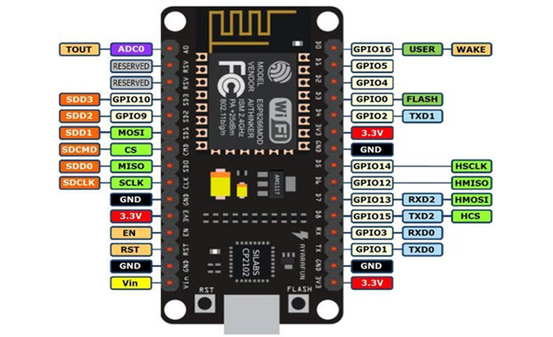Figure 3.4: NodeMCU ESP8266 Pinout

ADC | A0 | GPIO16

EN | Enable | GPIO14

D0 | GPIO16 | GPIO12

D1 | GPIO5 | GPIO13

D2 | GPIO4 | GPIO15

D3 | GPIO0 | GPIO2

D4 | GPIO2 | GPIO9

D5 | GPIO14 | GPIO10

D6 | GPIO12 | GPIO3

D7 | GPIO13 | GPIO1

D8 | GPIO15 | TX (GPIO1)

D9 | GPIO3 (RX) | RX (GPIO3)

D10 | GPIO1 (TX) | D11 (MOSI)

D11 | MOSI | D12 (MISO)

D12 | MISO | D13 (SCK

**ADC**: Analog-to-Digital Converter pin for reading analog sensor values.

**EN** (Enable): Enable pin.

**D0-D8**: Digital GPIO pins.

**D9 (RX) and D10 (TX)**: Serial communication pins for programming and debugging.

**D11 (MOSI), D12 (MISO), D13 (SCK**): Pins used for SPI communication.

**D14 (SDA) and D15 (SCL)**: Pins used for I2C communication.

It's important to note that GPIO pins labeled as "D" (Digital) are typically used for general-purpose digital input/output. Additionally, GPIO pins labeled as "A" (Analog) can be used as analog inputs with the ADC. GPIO pins 6, 7, 8, 9, 10, and 11 have additional functions, so it's advised to refer to the specific NodeMCU documentation for detailed information on pin functionality and capabilities.

**3.2 Soil Moisture Sensor:**

Soil moisture sensors are essential components in smart irrigation systems, playing a critical role in accurately measuring and monitoring soil moisture levels. These sensors utilize various technologies and mechanisms to detect the amount of water present in the soil, providing valuable data for irrigation management.Soil moisture sensors are typically installed at various depths within the soil profile to capture moisture variations across different soil layers. This multi-depth monitoring enables more accurate assessment of soil moisture distribution and helps determine the optimal irrigation schedule for different crop types and soil conditions.Additionally, advancements in sensor technology have led to the development of wireless and IoT-enabled soil moisture sensors, allowing for remote monitoring and real-time data transmission. These wireless sensors offer greater flexibility and accessibility, enabling farmers to monitor soil moisture levels from anywhere using mobile devices or web interfaces. Overall, soil moisture sensors are indispensable tools in modern agriculture, enabling precise irrigation management, water conservation, and improved crop productivity. By providing timely and accurate information about soil moisture levels, these sensors empower farmers to make informed decisions and optimize water usage, ultimately contributing to sustainable and efficient agricultural practices.

**Details Of Soil Moisture Sensor**

Soil moisture sensors are crucial devices used in agriculture to measure the water content in soil. Typically, they employ various technologies such as capacitance or resistance to gauge moisture levels accurately. These sensors are often designed to be inserted into the soil at different depths to provide comprehensive data on moisture distribution. As soil moisture increases, the sensor's output signal changes, allowing farmers to determine when irrigation is necessary. Modern soil moisture sensors may also feature wireless or IoT capabilities, enabling remote monitoring and real-time data transmission for enhanced convenience and efficiency. Overall, soil moisture sensors play a vital role in optimizing irrigation practices, conserving water, and promoting health plant growth.

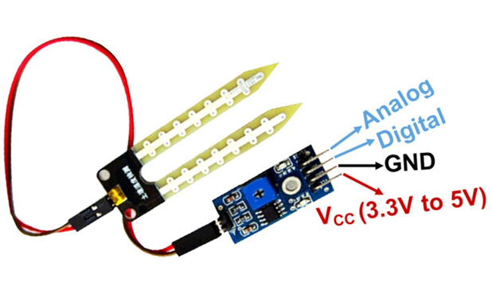

Figure 3.5: Soil moisture Sensor

**Technical Specifications of Soil Moisture sensor**

● Measure depths: 30 cm (11 in) – 100 cm(40 in).

● Range: 0 to 45% volumetric water content in soil

● Operating temperature: –40°C to +60°C

**Detect Soil Moisture levels using Digital pins:**

The pins used by a soil moisture sensor to detect soil moisture levels depend on the specific model of the sensor. However, most soil moisture sensors consist of two main probes or electrodes that are inserted into the soil. These probes are connected to the sensor's electronic circuitry, which typically includes pins for power, ground, and signal output. This pin outputs the signal that corresponds to the measured soil moisture level. Depending on the sensor's design, this output can be either analog or digital. For digital output sensors, the signal pin provides a binary signal (typically logic HIGH or LOW) indicating whether the soil moisture level is above or below a certain threshold.

**Measure Soil moisture Value using Analog Pin:**

Analog output soil moisture sensors provide a continuous voltage or current signal that varies proportionally with changes in soil moisture levels. The sensor's output signal typically ranges from a minimum value when the soil is dry to a maximum value when the soil is saturated with water. It's important to note that analog output sensors may require periodic recalibration to maintain accuracy, as factors such as soil composition, temperature, and sensor aging can affect the relationship between the output signal and soil moisture levels over time. Regular maintenance and calibration checks are essential to ensure reliable performance and accurate measurement results.

**Features of Soil Moisture Sensors:**

1. **Measuring Principle:** Soil moisture sensors utilize different measuring principles, such as capacitance or resistance, to determine soil moisture levels accurately.

2. **Measurement Range:** The range within which the sensor can measure soil moisture, usually expressed in percentage or volumetric water content (% or VWC).

3. **Accuracy:** The degree of precision or closeness of measurement compared to a known standard or true value, often specified as a percentage of the full-scale measurement range.

4. **Resolution:** The smallest increment of change in soil moisture that the sensor can detect and measure accurately.

5. **Response Time:** The time taken by the sensor to detect and respond to changes in soil moisture levels, typically expressed in seconds or minutes.

6. **Operating Temperature Range:** The range of temperatures within which the sensor can operate effectively without compromising accuracy or performance.

7**. Output Interface:** The type of output signal provided by the sensor, such as analog voltage, digital signal, or communication protocols (e.g., I2C, UART).

8. **Environmental Protection:** Specifications regarding the sensor's resistance to environmental factors such as moisture, dust, and temperature variations, often indicated by IP (Ingress Protection) ratings.

9. **Physical Dimensions:** The physical dimensions of the sensor, including length, width, and depth, which may vary depending on the sensor's design and intended application.

10. **Installation Requirements:** Guidelines for installing and mounting the sensor in soil, including recommended depth and spacing between sensors for optimal performance.

11.**Calibration:** Information on calibration procedures and requirements to ensure accurate measurement of soil moisture levels over time.

12.**Wireless or IoT Capabilities:** Some soil moisture sensors feature wireless or IoT capabilities, allowing for remote monitoring and real-time data transmission for enhanced convenience and efficiency.

**3.3 Temperature and Humidity Sensor:**

**Temperature and Humidity Sensor**

A temperature sensor is a device that measures the temperature of its surroundings or a specific object and converts that temperature into an electrical signal. Temperature sensors are used in a wide range of applications, including industrial processes, environmental monitoring, consumer electronics, medical devices, and more.

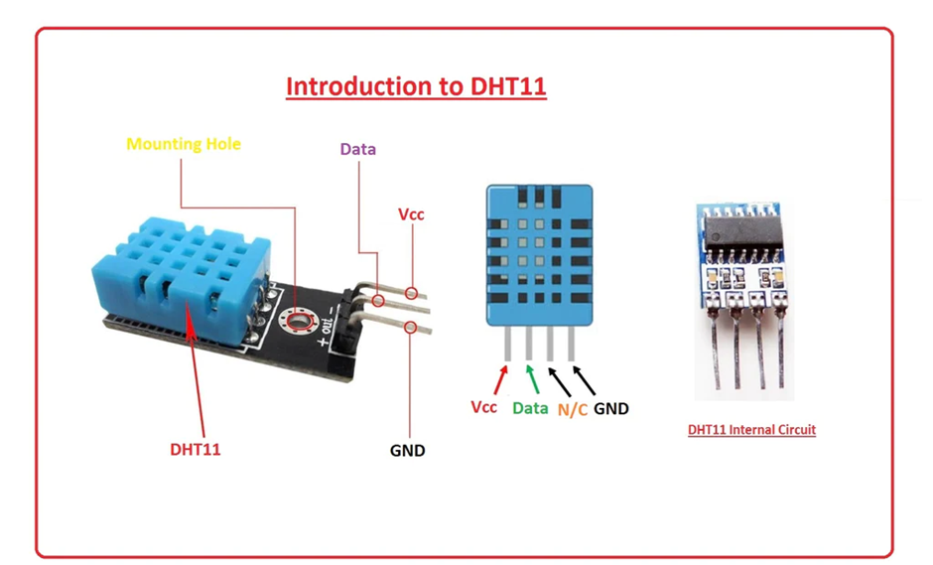

Figure 3.6 DHT 11 sensor

**Features of Temperature Sensors:**

1. **Accuracy:** Temperature sensors should provide accurate readings to ensure precise temperature measurements.

2. **Range:** They should be able to measure temperatures within a specific range, which can vary from sensor to sensor.

3. **Response Time:** The time it takes for a sensor to detect and report a change in temperature.

4. **Resolution:** The smallest temperature difference that a sensor can detect and report.

5. **Stability:** Consistency of readings over time and in various conditions.

6. **Calibration:** Some temperature sensors might need periodic calibration to maintain accuracy.

7. **Output Type:** Temperature sensors can provide analog or digital outputs, depending on the type of sensor.

8. **Sensitivity Adjustments:**

Sensitivity adjustment in a temperature sensor refers to the ability to fine-tune the sensor's response to temperature changes. Some sensors offer the option to adjust sensitivity to match specific requirements or to compensate for external factors that might affect accuracy.

**Principle of Temperature Measurement:**

Different types of temperature sensors work based on various principles. Some common principles include

**Thermocouples:** These sensors use the Seebeck effect, where two different metals connected at two junctions produce a voltage proportional to the temperature difference between the junctions. The voltage generated is used to determine the temperature.

**RTDs (Resistance Temperature Detectors):** RTDs are based on the principle that the electrical resistance of a material changes with temperature. They use materials with a predictable resistance-temperature relationship, such as platinum, to measure temperature.

**Thermistors:** Thermistors are temperature-sensitive resistors that have a resistance that changes significantly with temperature. They can be either Negative Temperature Coefficient (NTC) or Positive Temperature Coefficient (PTC) thermistors.

**Infrared Sensors:** These sensors detect the infrared radiation emitted by an object to calculate its temperature. They are particularly useful for non-contact temperature measurement.

**Bimetallic Strips:** Bimetallic strips consist of two different metals with different coefficients of thermal expansion bonded together. As the temperature changes, the strip bends due to the differential expansion, and this bending can be used to measure temperature.

**Semiconductor Temperature Sensors:** These sensors use the temperature-dependent properties of semiconductors, such as diodes or transistors, to measure temperature.

## **3.5 Relay Module:**

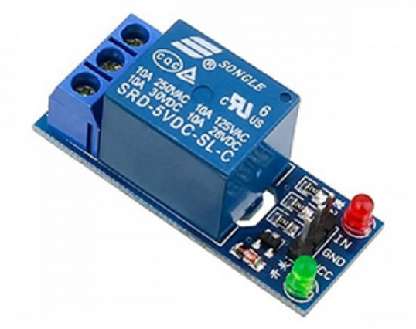

Figure 3.7 Relay Module

A relay sensor, also known as a relay switch or simply a relay, is an electrical component that functions as an electromagnetic switch. It operates by using a small control signal to activate a larger load or circuit. Relays are commonly used in various applications to control high-power devices or circuits using low-power signals. They are widely used in automation, industrial control systems, automotive systems, and more.

**Features of a Relay Sensor:**

**Switching Capability:** Relays can switch high-power circuits using a low-power control signal.

**Isolation:** They provide electrical isolation between the control circuit and the load circuit.

**Longevity:** Relays have a longer operational life compared to mechanical switches. **Versatility:** They can be used for various types of loads, including AC and DC circuits.

**Sensitivity Adjustments:** Some relays allow sensitivity adjustments, which control the level of input signal required to trigger the switch.

**Sensitivity Adjustments:** Sensitivity adjustments in a relay refer to the ability to control the activation threshold of the relay. This adjustment allows you to specify the minimum input signal strength

required to trigger the relay's switch. It's usually achieved by modifying the characteristics of the electromagnetic coil or using external components to adjust the sensitivity level.

**Principle of Operation:**

The principle of a relay's operation is based on the electromagnetic effect. A relay consists of two main parts: an electromagnetic coil and a set of contacts. When a control signal (usually a voltage or current) is applied to the coil, it generates a magnetic field. This magnetic field causes the contacts to move, either making or breaking the connection between the load circuit and the control circuit.

**Specifications in Mathematical Terms:**

Here are some common specifications of a relay that can be represented mathematically:

**Contact Rating (CR):** This represents the maximum current and voltage the relay contacts can handle:

CR = Max Current (A) × Max Voltage (V)

**Coil Voltage (V_coil):** The voltage applied to the electromagnetic coil to activate the relay.

**Coil Resistance (R_coil):** The resistance of the electromagnetic coil, which determines the current flowing through it:

R_coil = V_coil / I_coil

**Operate Time (t_operate):** The time taken by the contacts to close after the coil is energized.

**Release Time (t_release):** The time taken by the contacts to open after the coil is de-energized.

**Switching Time (t_switch):** The total time taken for the contacts to transition from open to closed or vice versa.

**Sensitivity Adjustment (SA):** A coefficient indicating the sensitivity adjustment level, usually expressed as a percentage.

**CHAPTER 4**

# **Design and Coding**

Creating a smart irrigation system using NodeMCU involves both hardware setup and software coding. Below is a high-level overview of the design and coding process:

**1. Hardware Components:**

* **NodeMCU (ESP8266/ESP32):** Microcontroller with built-in Wi-Fi.
* **Soil Moisture Sensor:** Measures soil moisture levels.
* **Relay Module:** Controls the water pump or solenoid valve.
* **Water Pump/Solenoid Valve:** Manages the water flow.
* **Power Supply:** For NodeMCU and connected devices.
* **Optional Components**: Temperature & humidity sensors (DHT11/22), water level sensors, etc.

**2. Circuit Design:**

**-Soil Moisture Sensor:**

- Connect the VCC to the 3.3V on NodeMCU.

- Connect the GND to GND on NodeMCU.

- Connect the Analog/Data Out to an analog input pin on NodeMCU (e.g., A0).

**- Relay Module:**

- Connect the VCC to the 3.3V or 5V (depending on relay specs).

- Connect the GND to GND.

- Connect the IN to a digital output pin (e.g., D1) on NodeMCU.

- Connect the Common and normally open terminals of the relay to the water pump or solenoid valve.

**-Water Pump/Solenoid Valve:**

- Connect one terminal to the relay.

- Connect the other terminal to the power source.

**3. Testing and Calibration:**

- Calibrate the soil moisture sensor to determine the optimal moisture level.

- Test the relay operation to ensure the pump turns on/off as expected.

- Verify Wi-Fi connectivity and remote control functionality.

**4. Deployment:**

- Assemble the components in a waterproof enclosure for outdoor use.

- Provide stable power to the system.

- Monitor and adjust the system based on real-time data.

This setup can be further enhanced with more sophisticated algorithms, machine learning for predictive irrigation, and integration with weather APIs to adjust watering schedules based on forecasted conditions.

**CHAPTER 5**

**CIRCUIT DIAGRAM**

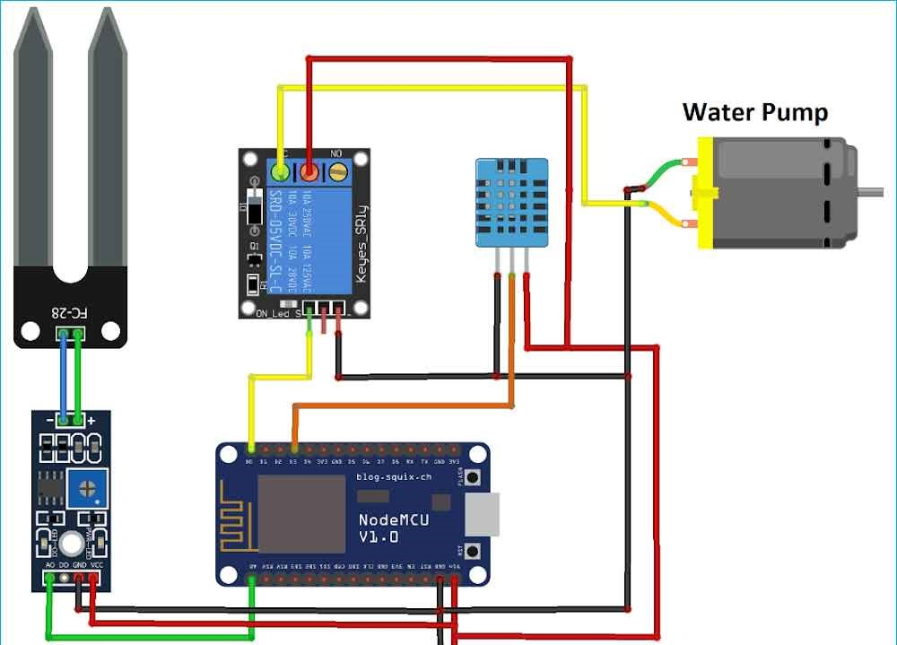

**PROTOTYPE**

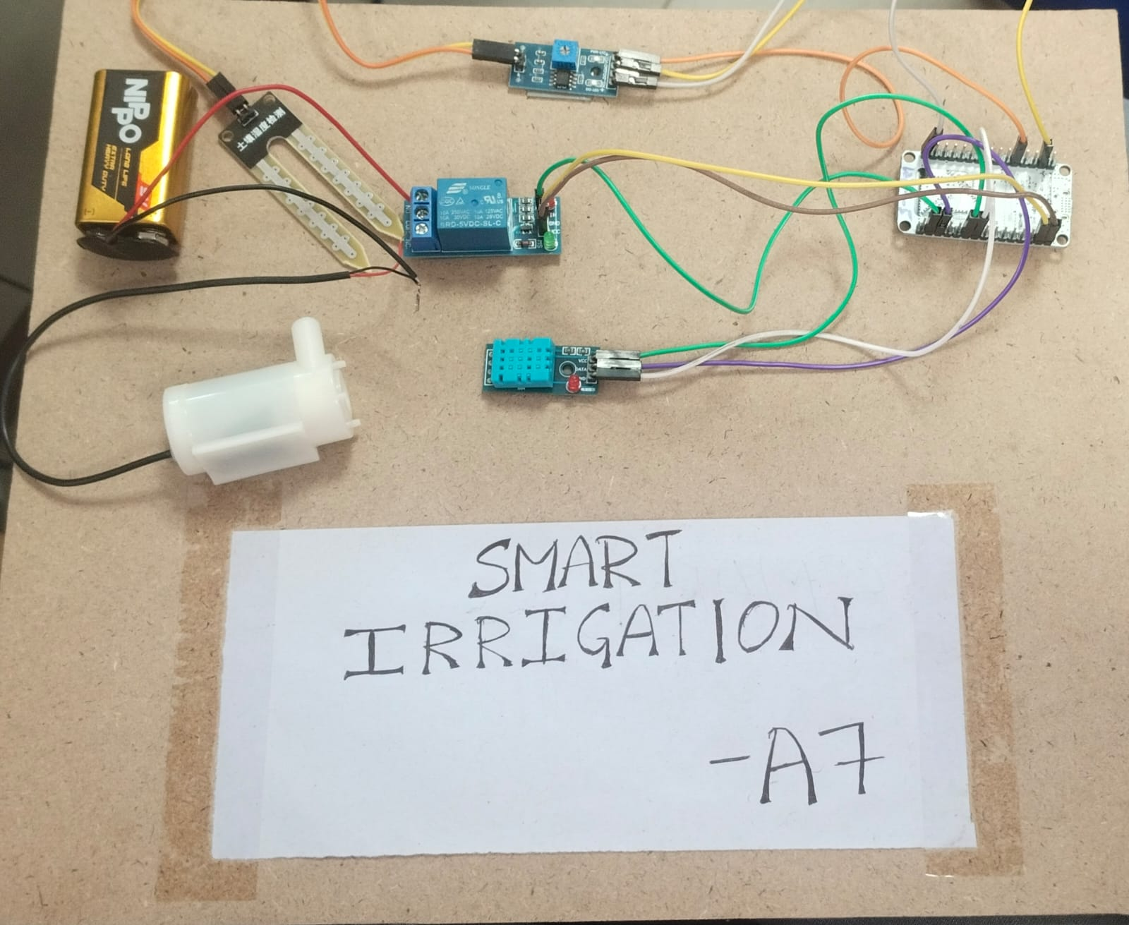

**CHAPTER 6**

**CONCLUSION**

In conclusion, developing a smart irrigation system using NodeMCU and integrating it with MIT App Inventor offers a versatile and efficient solution for water management in agriculture or home gardening. This approach combines the power of IoT with user-friendly mobile control, allowing for real-time monitoring and management of irrigation processes from anywhere.

With MIT App Inventor, users can easily create a custom mobile application that interfaces with the NodeMCU to control irrigation based on soil moisture levels, weather conditions, and predefined schedules. This not only conserves water but also ensures that plants receive the optimal amount of moisture, leading to healthier growth and more sustainable water usage.

Overall, the integration of hardware, software, and mobile applications creates a robust and scalable system that can be tailored to various needs, from small gardens to large-scale agricultural operations. This project demonstrates the potential of smart technology in enhancing agricultural practices, promoting sustainability, and making water management more efficient and convenient.